**PIZZA SALES QUERIES**

1. **KPIS**
2. **Total revenue**

**---total revenue**

**select Sum(total_price) as total_revenue from pizza_sales;**

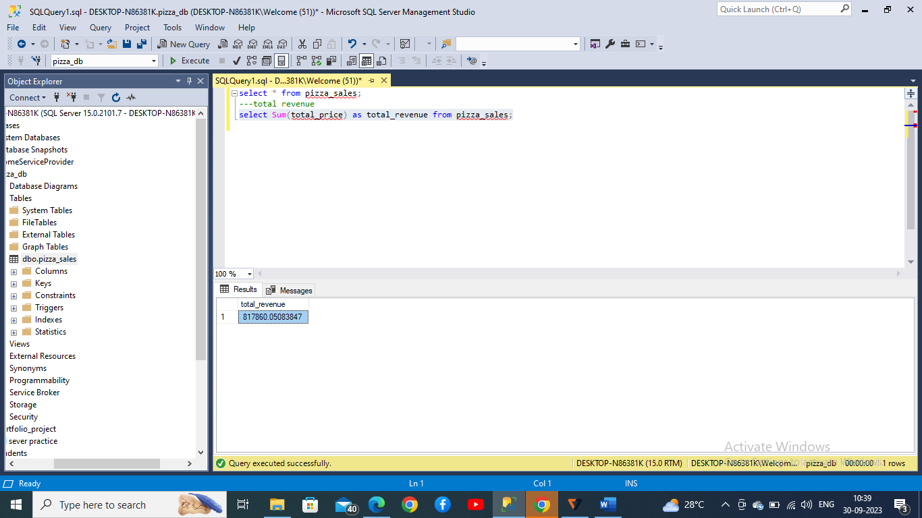

1. **Average order value**

**---average order value**

**select sum(total_price)/count(distinct order_id) as average_order_value from pizza_sales;**

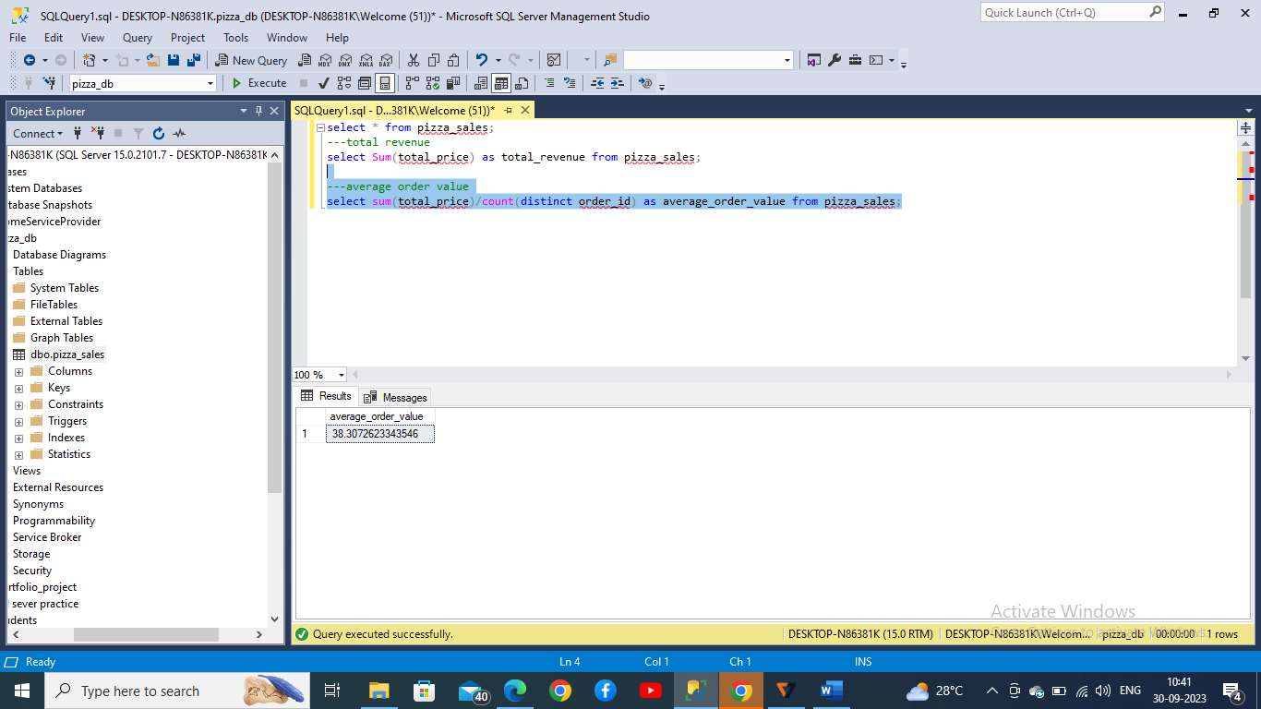

1. **Total pizzas sold**

**--total pizzas sold**

**select sum(quantity) as total_pizzas from pizza_sales;**

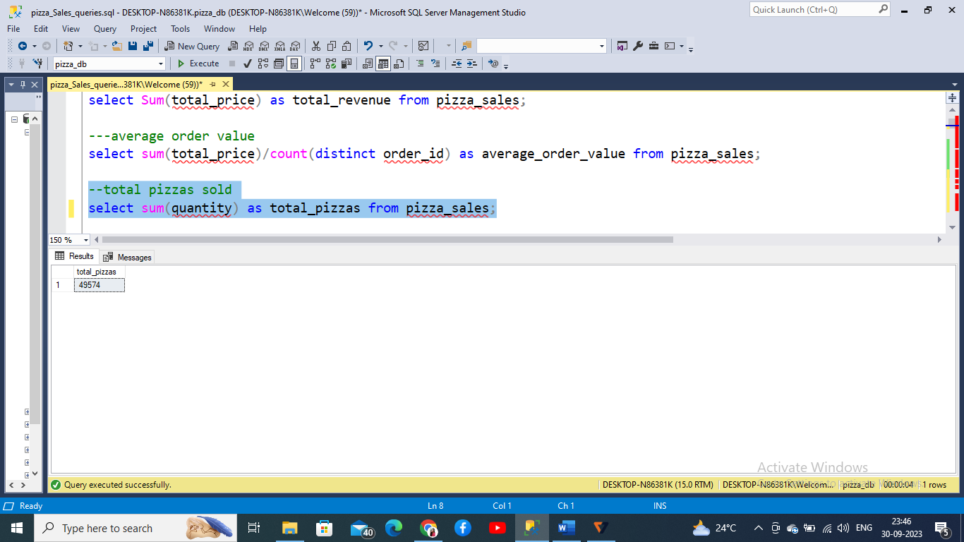

1. **Total orders placed**

**--total orders placed**

**select count(distinct order_id) as total_orders from pizza_Sales**

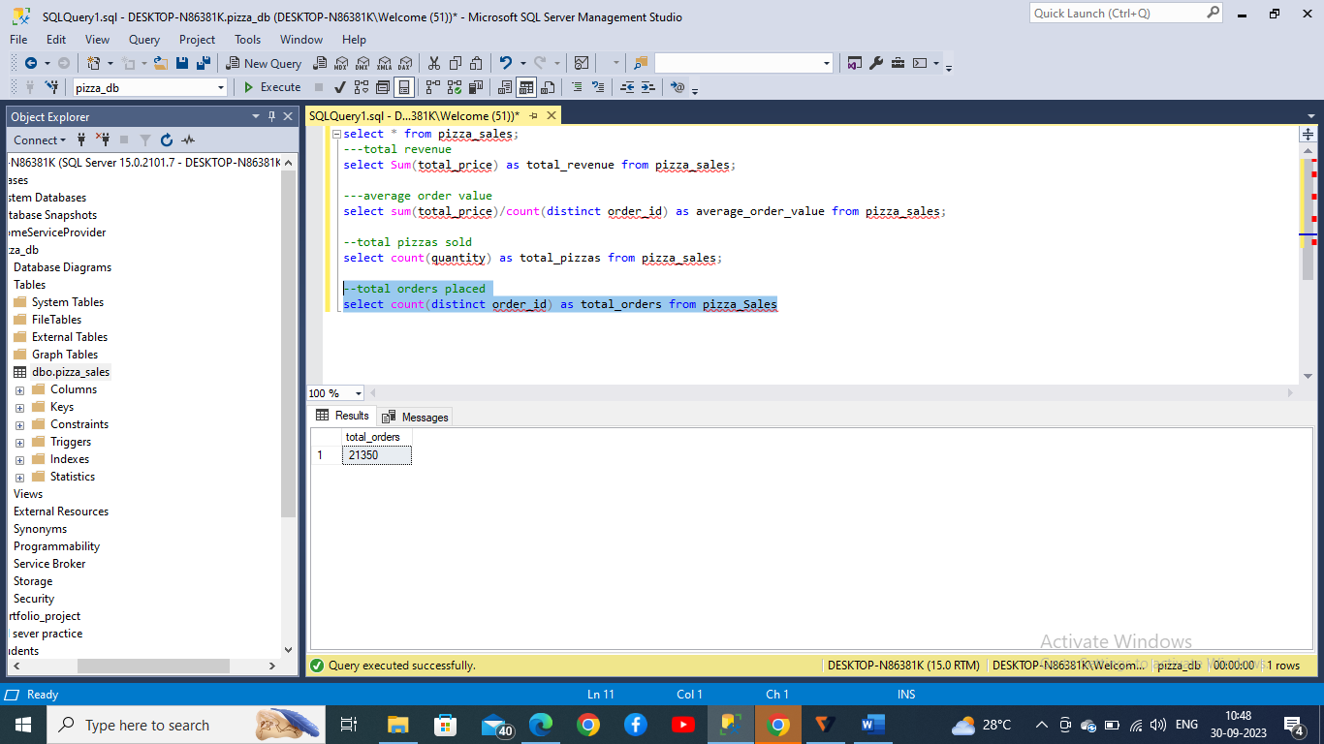

1. **Average pizzas per order**

**--average pizzas per order**

**select cast(cast(sum(quantity) as decimal(10,2))/cast(count(distinct order_id) as decimal(10,2))as decimal (10,2))**

**as average_pizzas_per_order from pizza_sales**

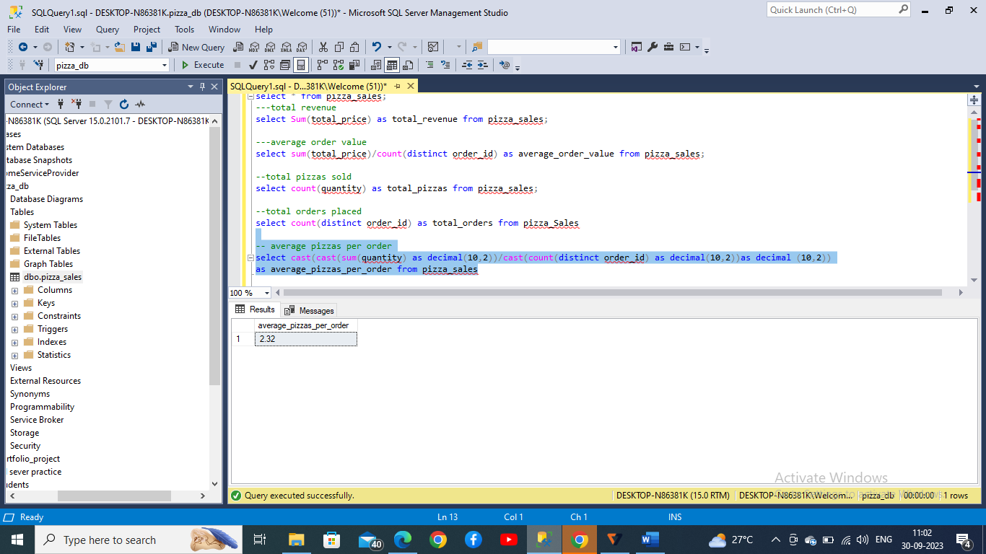

1. **Daily trend of pizzas**

**-- daily trend for pizzas**

**select datename(dw,order_date) as order_day,count(distinct order_id) as**

**total_orders from pizza_sales group by datename(dw,order_date)**

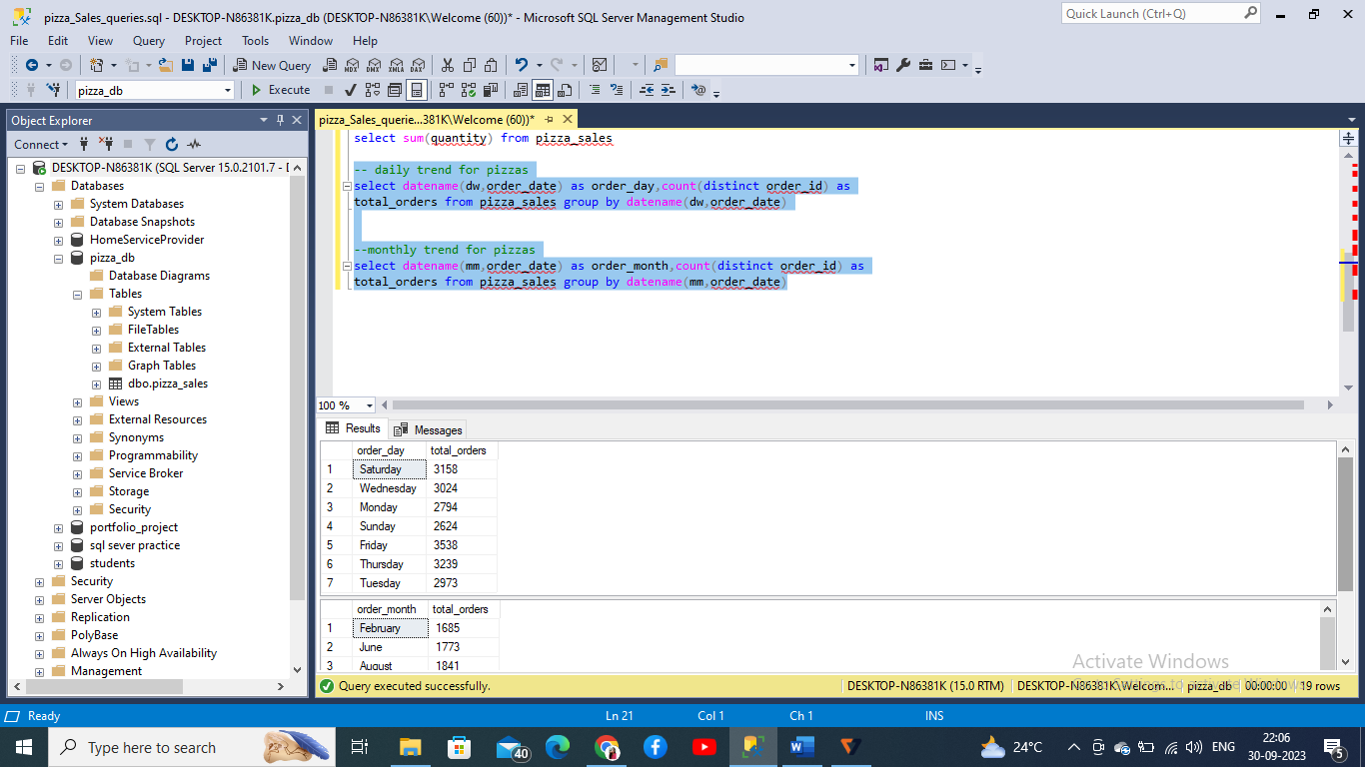

1. **Monthly trend of pizzas**

**--monthly trend for pizzas**

**select datename(mm,order_date) as order_month,count(distinct order_id) as**

**total_orders from pizza_sales group by datename(mm,order_date)**

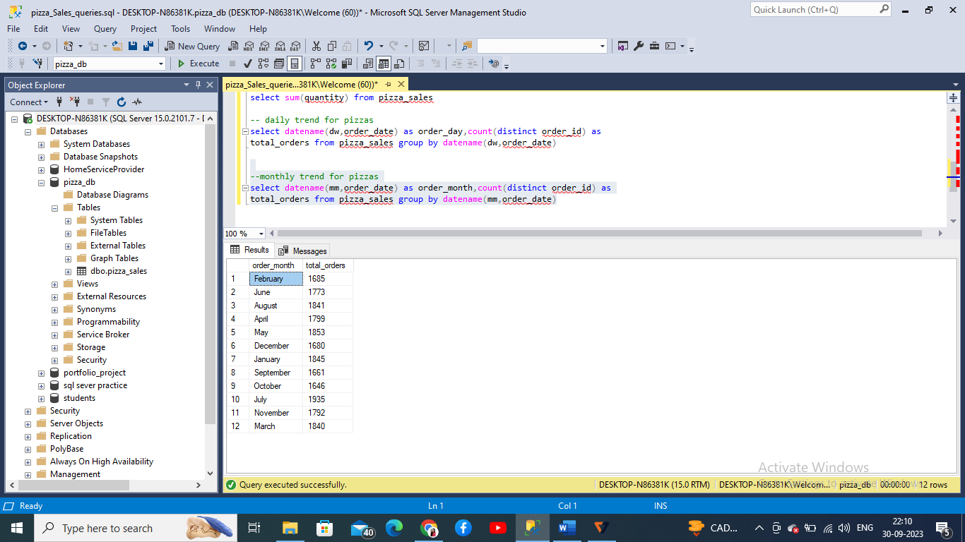

1. **Percentage of sales by pizza category**

**--total percentages of sales by pizza category**

**select pizza_category ,round(sum(total_price),2) as total_sales,**

**round((sum(total_price)*100/(select sum(total_price) from pizza_sales where month(order_date)=1) ),3)**

**as pct**

**from pizza_sales**

**where month(order_date)=1**

**--1 - january month**

**group by pizza_category**

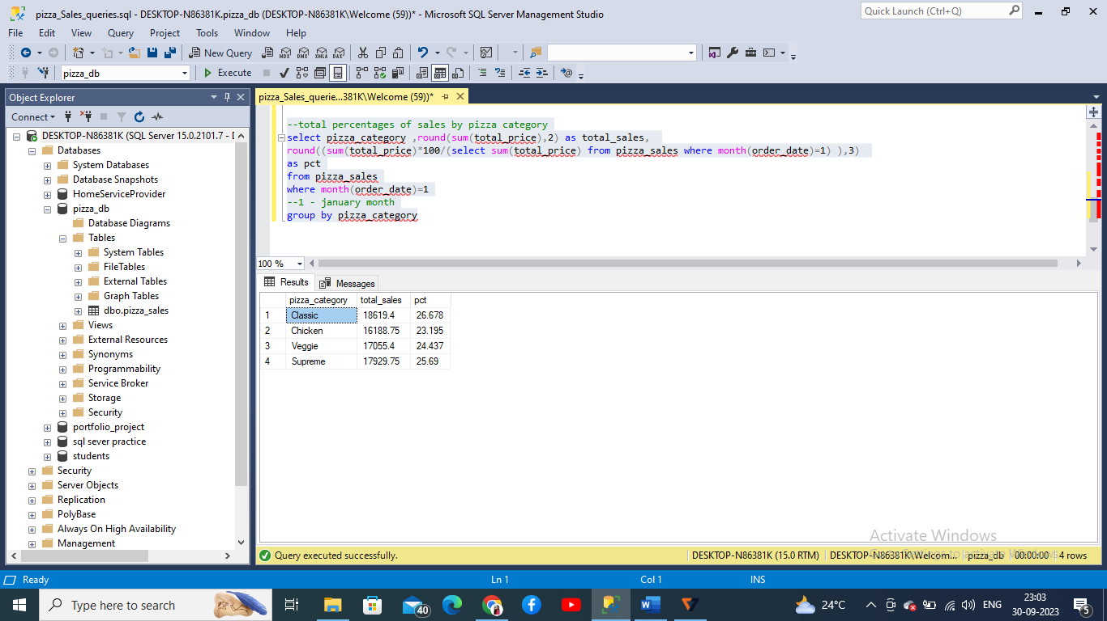

1. **Percentage of pizza sales by pizza size**

**select pizza_size, sum(total_price) as ts , sum(total_price) *100 / (select sum(total_price) from pizza_sales) as pst from pizza_sales group by pizza_size**

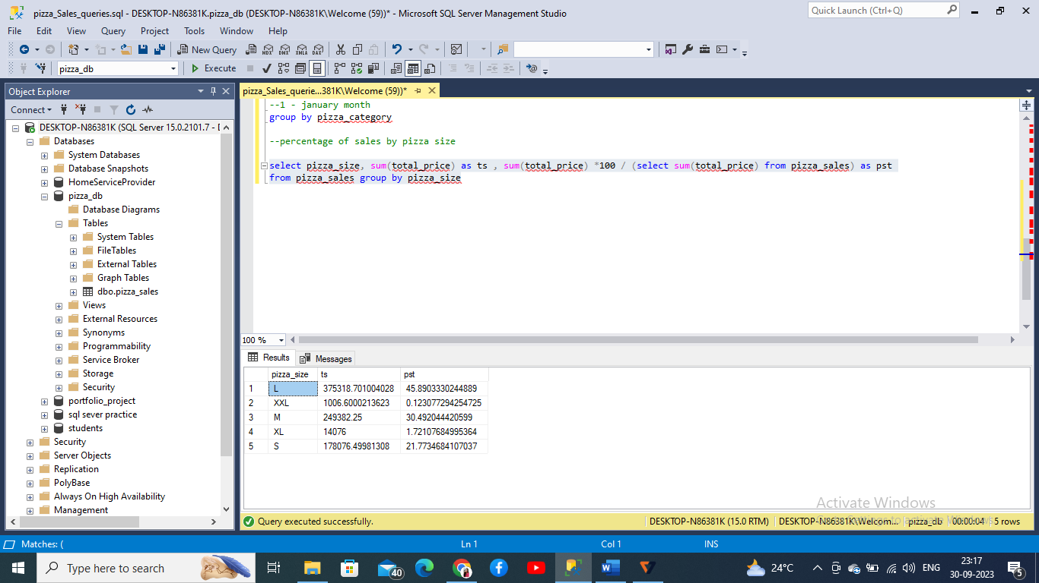

1. **Top 5 best sellers by revenue**

**--top 5 pizza names by revenue**

**select top 5 pizza_name , round(sum(total_price),2) as total_revenue from pizza_sales group by pizza_name**

**order by total_revenue desc**

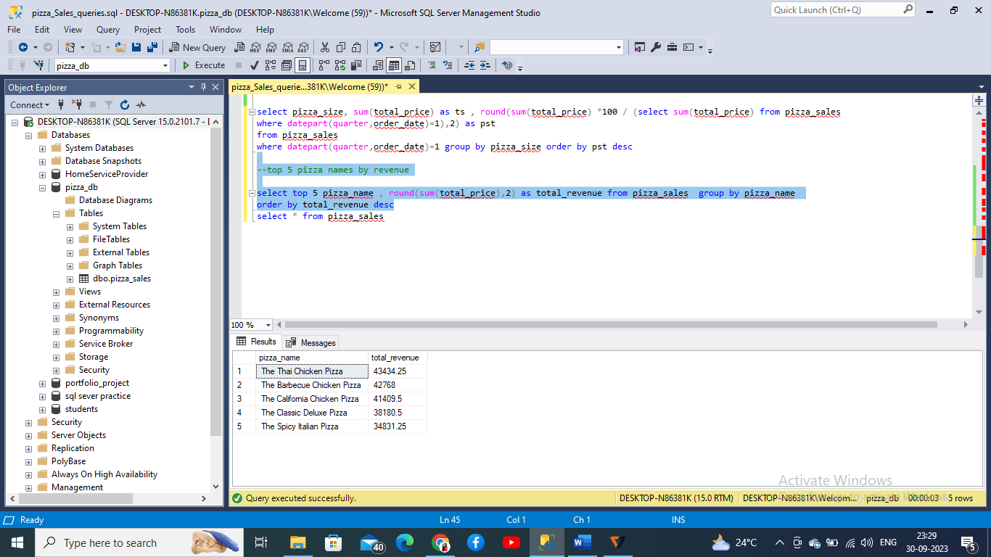

**--- bottom 5 pizza names by revenue**

**select top 5 pizza_name , round(sum(total_price),2) as total_revenue from pizza_sales group by pizza_name**

**order by total_revenue asc**

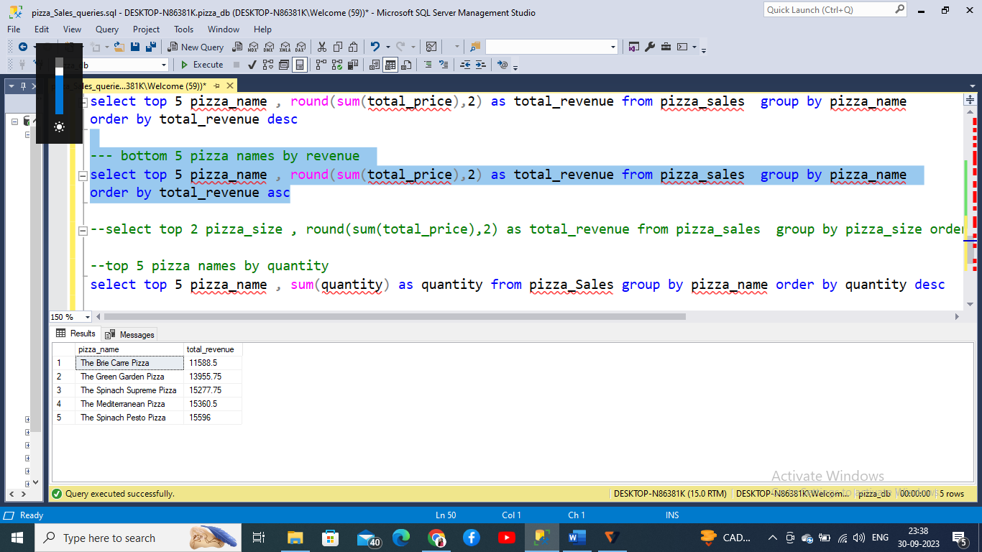

1. **Top 5 pizza names by quantity**

**--top 5 pizza names by quantity**

**select top 5 pizza_name , sum(quantity) as quantity from pizza_Sales group by pizza_name order by quantity desc**

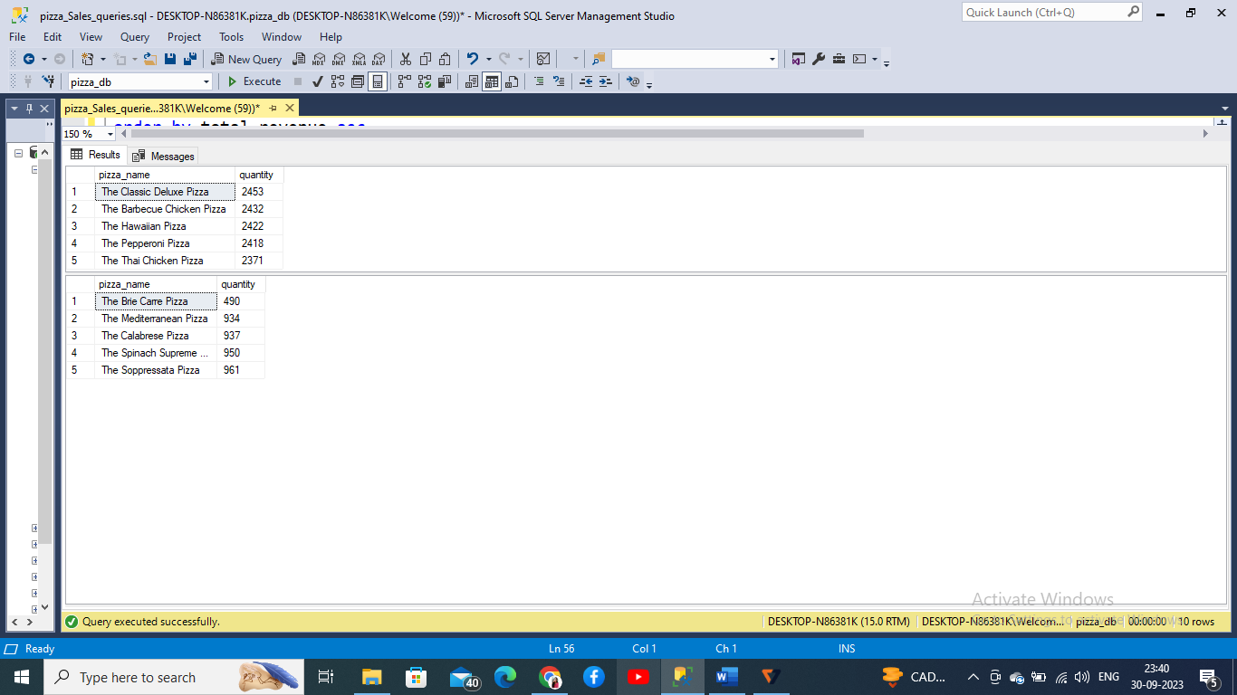

**--bottom 5 pizza names by quantity**

**select top 5 pizza_name , sum(quantity) as quantity from pizza_Sales group by pizza_name order by quantity asc**



1. **Top 5 by orders**

**-- top 5 by orders**

**select top 5 pizza_name , count(order_id) as orders from pizza_Sales group by pizza_name order by orders desc**

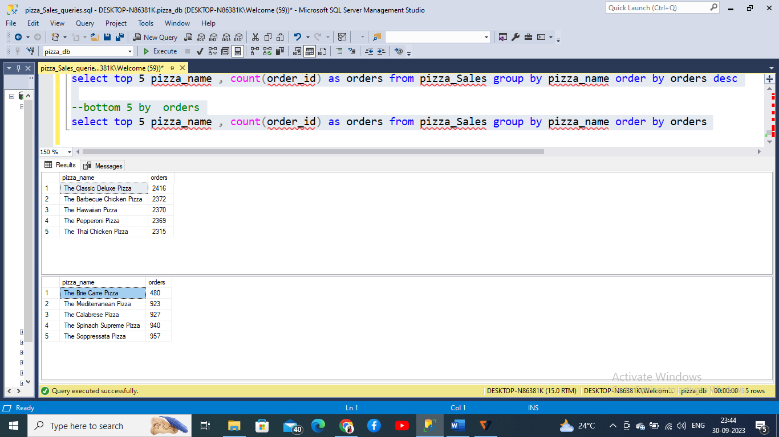

**bottom 5 by orders**

**select top 5 pizza_name , count(order_id) as orders from pizza_Sales group by pizza_name order by orders**

